lab ASSIGNMENT A11.2

GraphicPolygon

Background:

In Lab Assignment A6.2, we created a RegularPolygon class that maintained a large number of properties for any polygon of a given number and length of sides. By extending the RegularPolygon class to include the capabilities of the DrawingTool class, it is possible to display a graphic representation of any polygon. For example, a 9-sided regular polygon (nonagon) would be represented as follows:
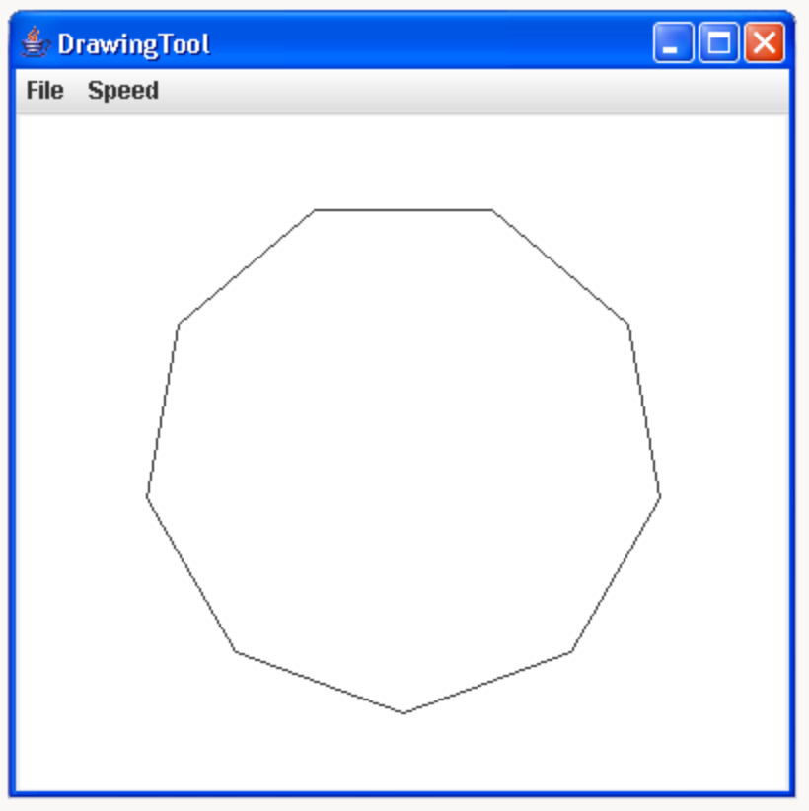

Assignment:

1. Extend the RegularPolygon class created in Lab Assignment A6.2 to create a GraphicPolygon class. Use the following declarations as a starting point for your lab work.

class GraphicPolygon extends RegularPolygon{
private DrawingTool pen = new DrawingTool(new SketchPad(400, 400));
private double xPosition, yPosition;

// constructors

// Initializes a polygon of numSides sides and sideLength
// length in the superclass. The polygon is centered at
// xPosition = yPosition = 0
public GraphicPolygon(int numSides, double sideLength){
}

// Initializes a polygon of numSides sides and sideLength
// length in the superclass. The polygon is centered at
// xPosition = x and yPosition = y
public GraphicPolygon(int numSides, double sideLength, double x, double y){
}

// public methods

// Sets xPosition = x and yPosition = y to correspond to the new
// center of the polygon
public void moveTo(double x, double y){
}

// Draws the polygon about the center point (xPosition, yPosition).
// Uses properties inherited from RegularPolygon to determine the
// number and length of the sides, the radius of the inscribed circle,
// and the vertex angle with which to draw the polygon
public void draw(){
}
}

2. Write two constructor methods. The first constructor initializes the number and length of the sides of a polygon centered about the point (0, 0). The Second constructor is used to initialize a polygon a specified number and length of sides with a center at a specified x and y location.

3. Write a method that draws the polygon onto the Sketchpad window using the movement and drawing methods available in the DrawingTool class.

4. Write a method that moves the center of the polygon to a specified x and y location.

5. Write a testing class with a main() method that constructs a GraphicPolygon and calls each method. Sample usage for a polygon with 9 sides of length 100 would give:

GraphicPolygon gPoly = new GraphicPolygon(9, 100);
gPoly.draw();

Instructions:

1. Use the following values to test your functions:

Square: number of sides = 4, length of side = 150
Octagon: number of sides = 8, length of side = 100
Enneadecagon: number of sides = 19, length of side = 50
Enneacontakaihenagon: number of sides = 91, length of side = 10

